Step#1: Open Eclipse Workplace

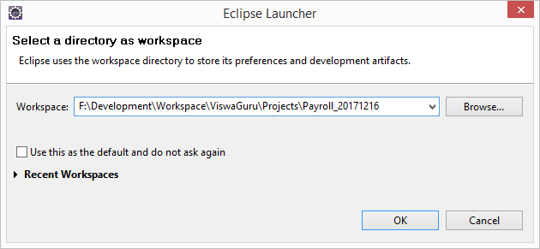

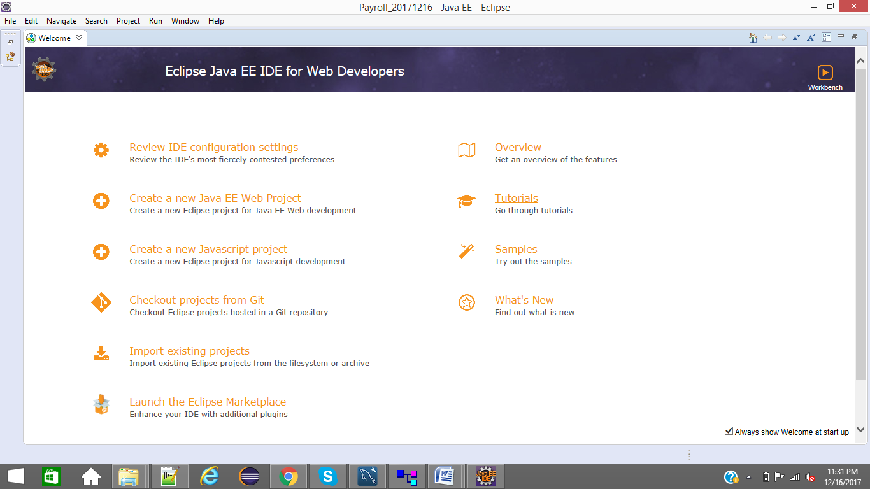

Step#2: Open GIT perspective

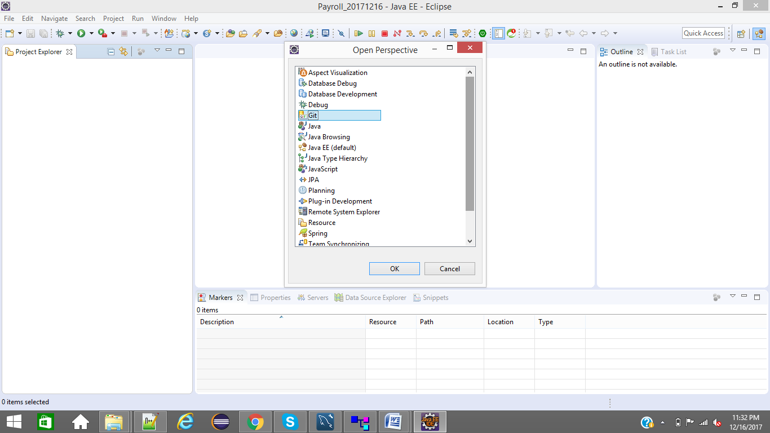

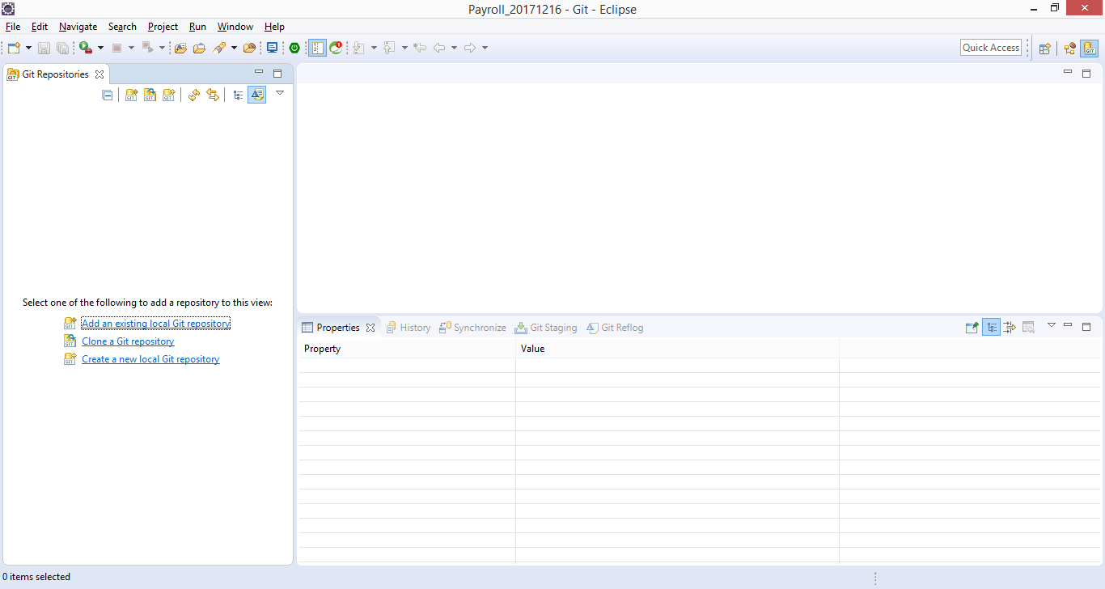

Step#3: Click on Clone a GIT Repository link and provide below GIT Repository details

URL: https://github.com/ram040284/Payroll.git

User: ram040284, Password:

Click on Next button

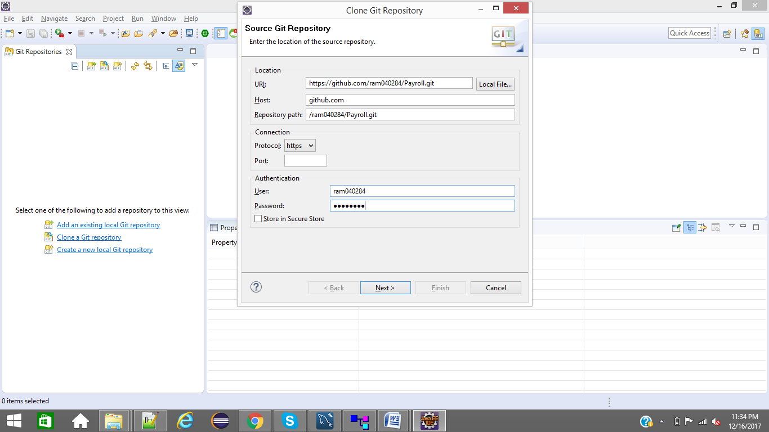

Select Payroll_01_201712 branch

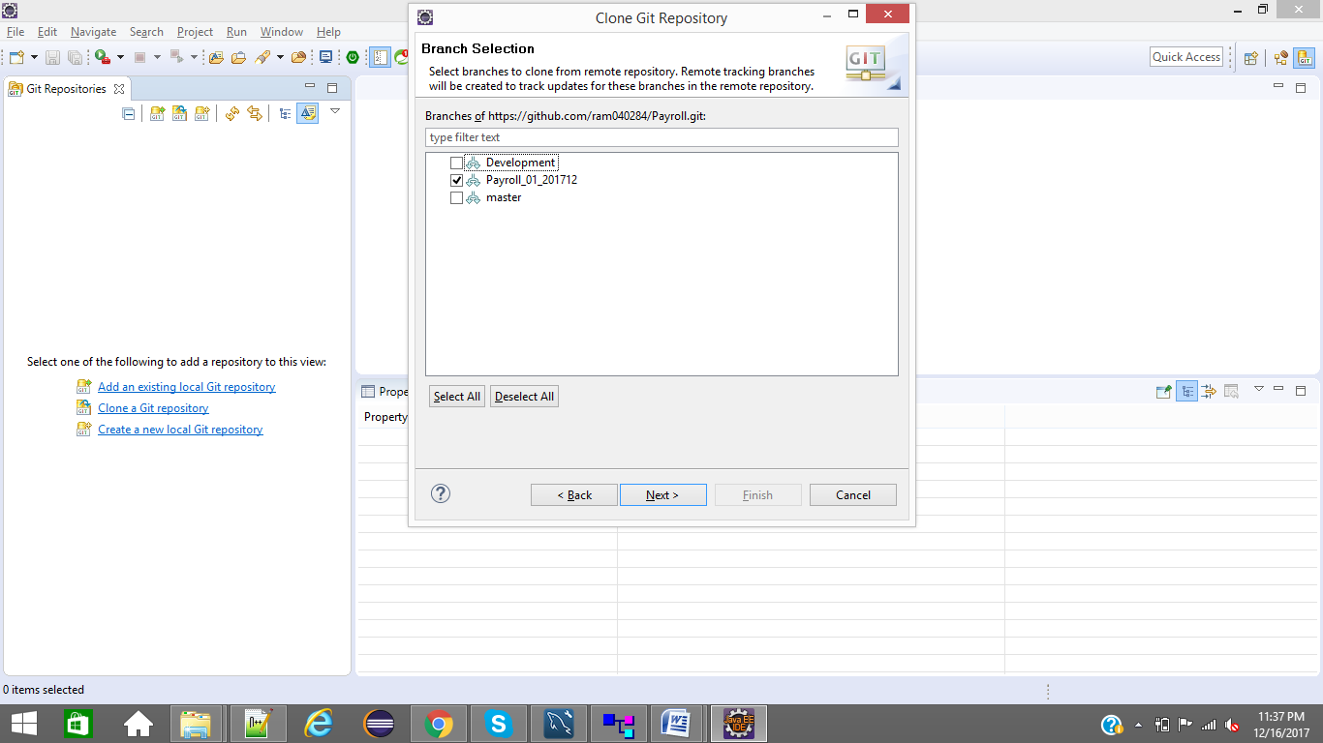

Choose Local Repository Destination folder

check Import all Eclipse projects after clone finishes

Click on finish button

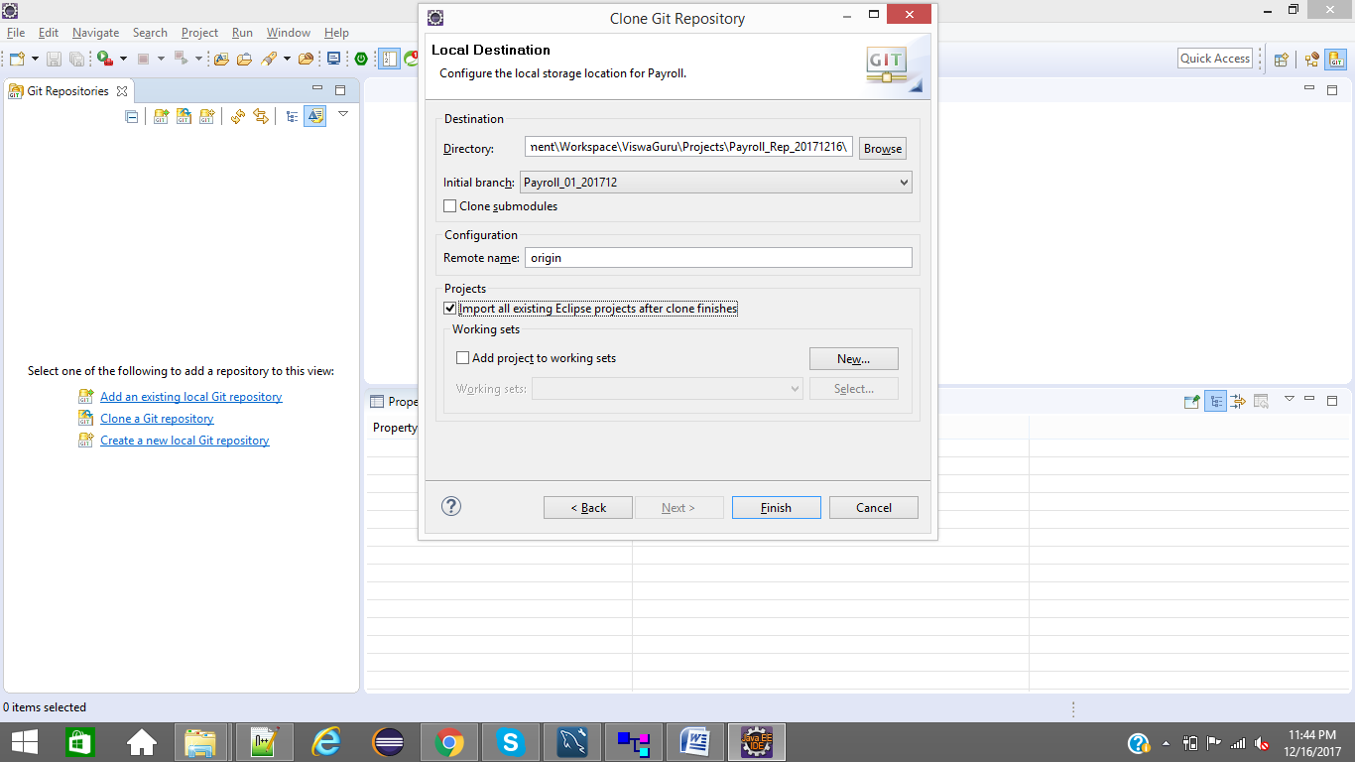

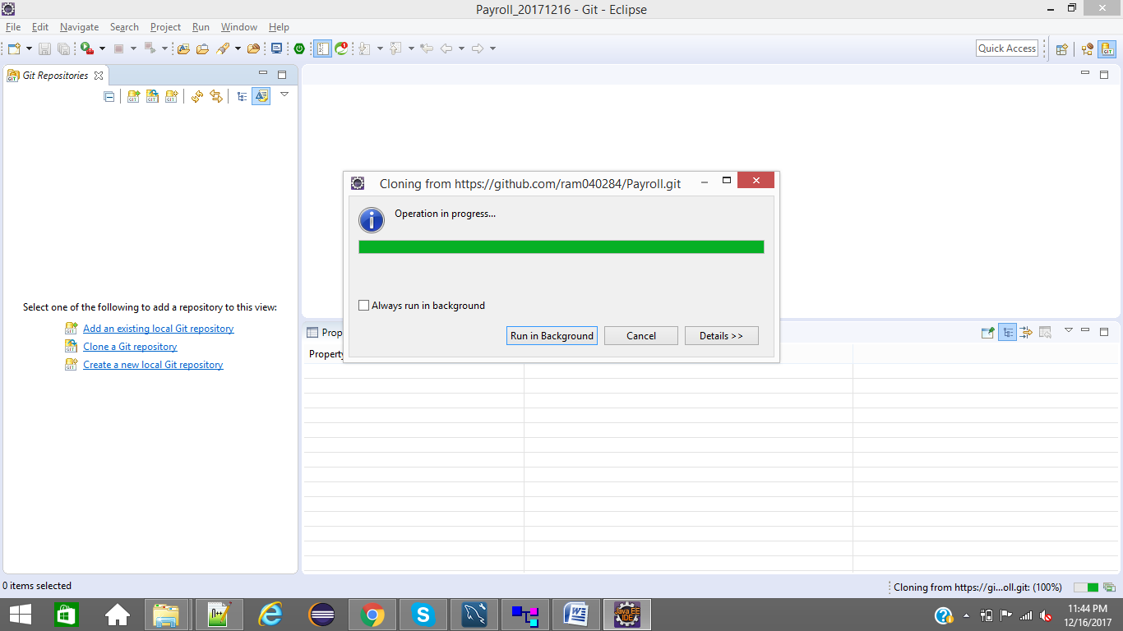

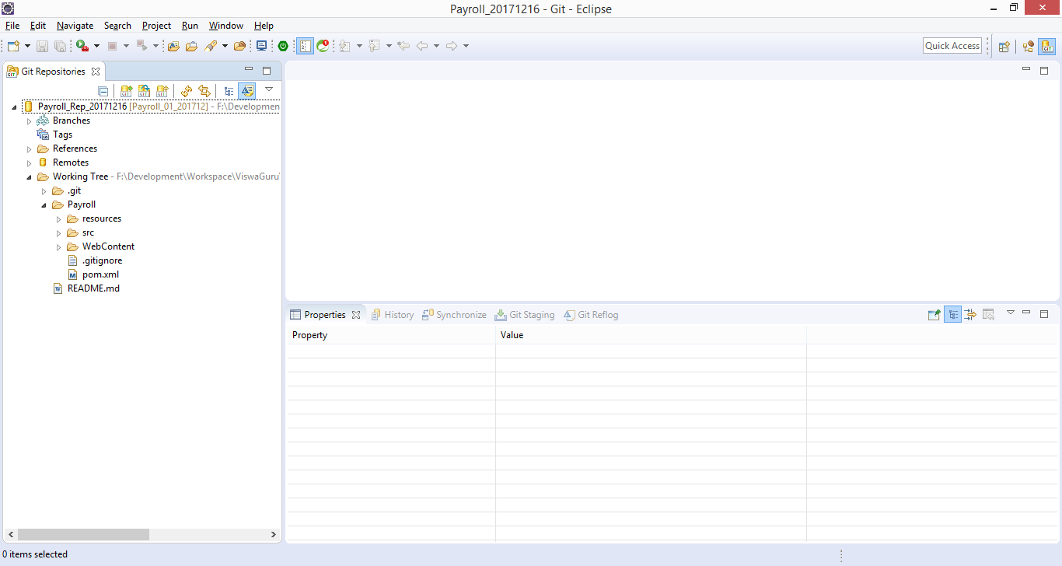

Step#4: check J2ee Perspective to confirm project is imported to eclipse or not

if not imported, please do step#5

if imported, please do step#6

Step#5: Right click on Payroll and Import Projects

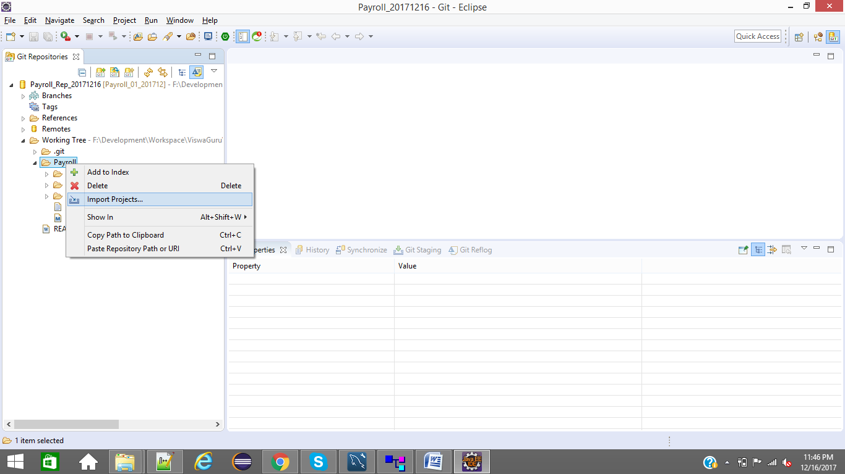

Click on Finish Button

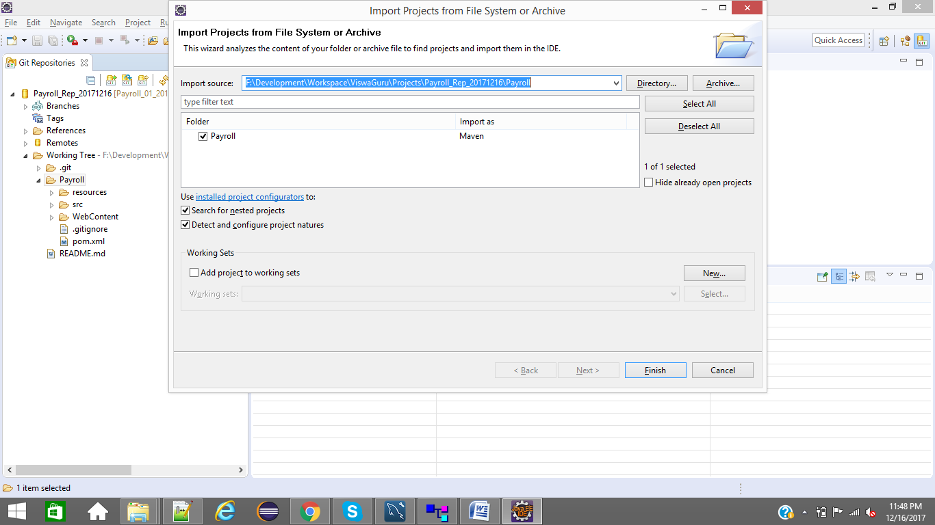

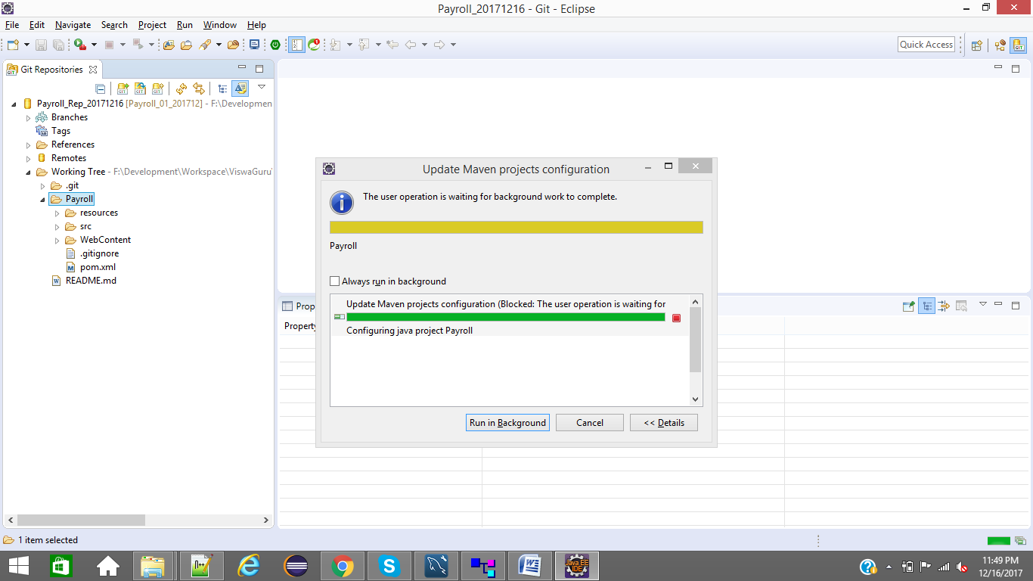

Step#6: Change to J2ee perspective. you can see imported project

Remove bin folder if you get in project structure

Open project properties and set Java compiler to 1.7

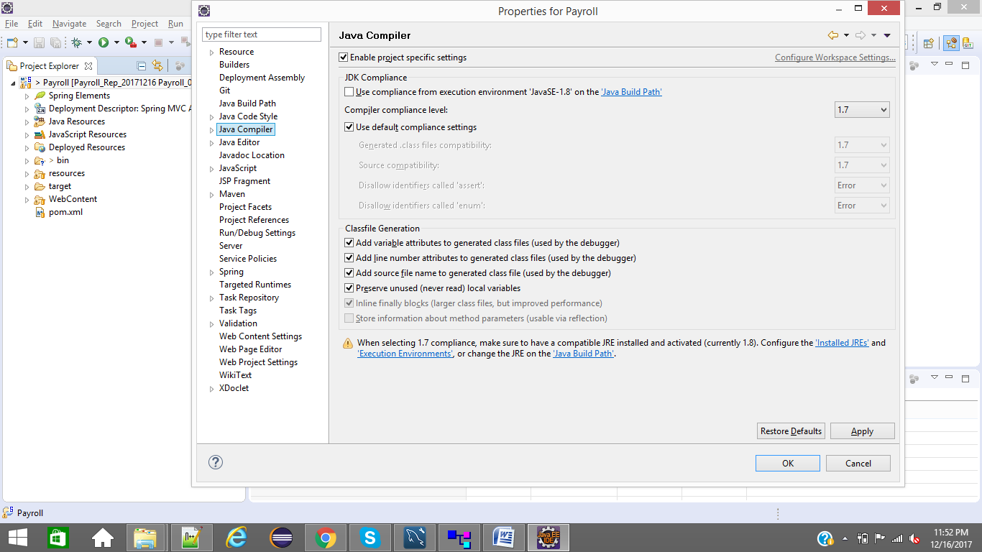

Project Properties - Project facets

Dynamic Web Module - 2.4, Java - 1.7, Java Script - 1.0

Click on Apply button and ok button

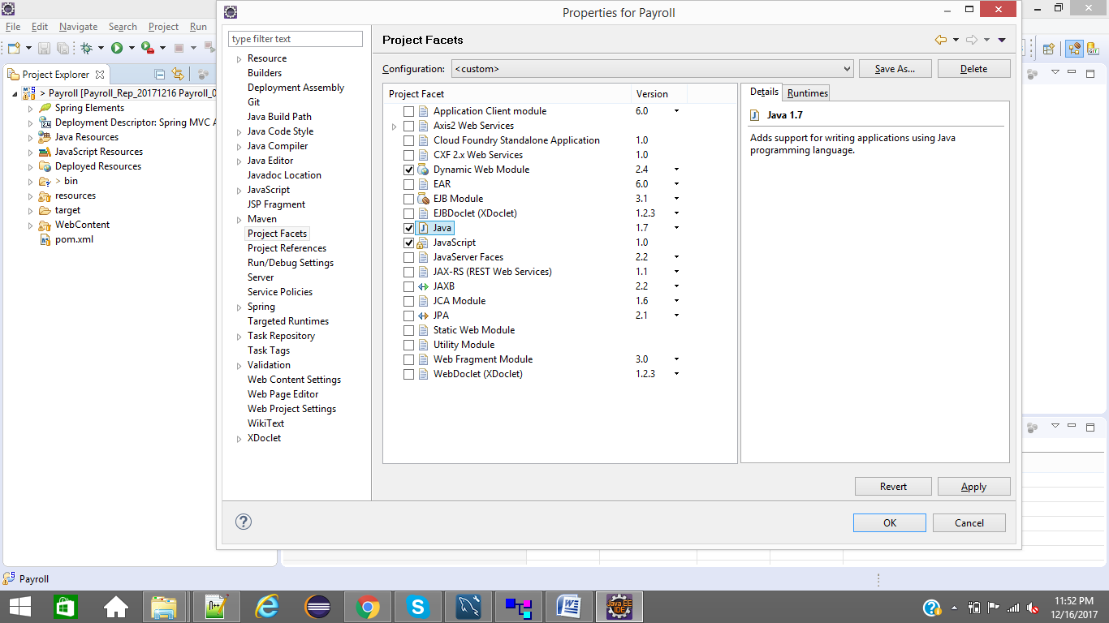

Step7: Verify MySQL Database details in hibernate configuration file

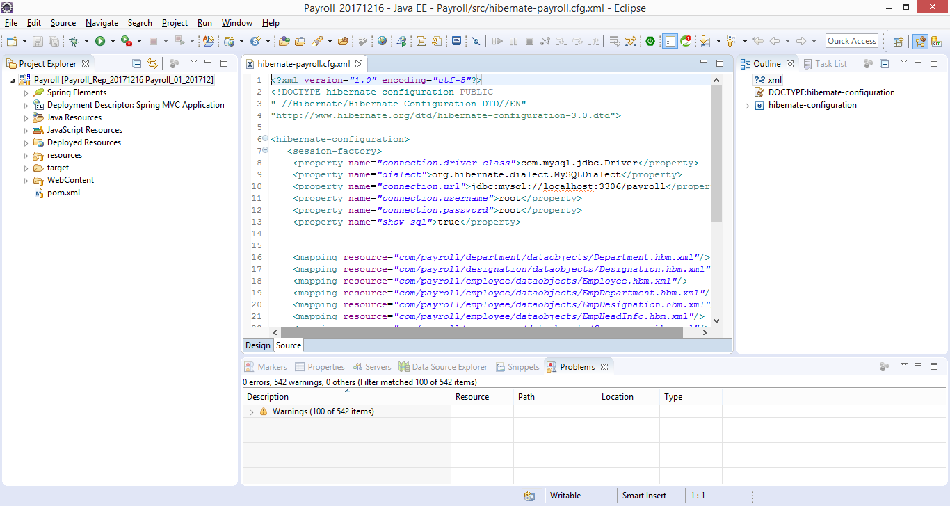

Step 8: Add Apache Tomcat Sever 7.0 or higher to the workspace

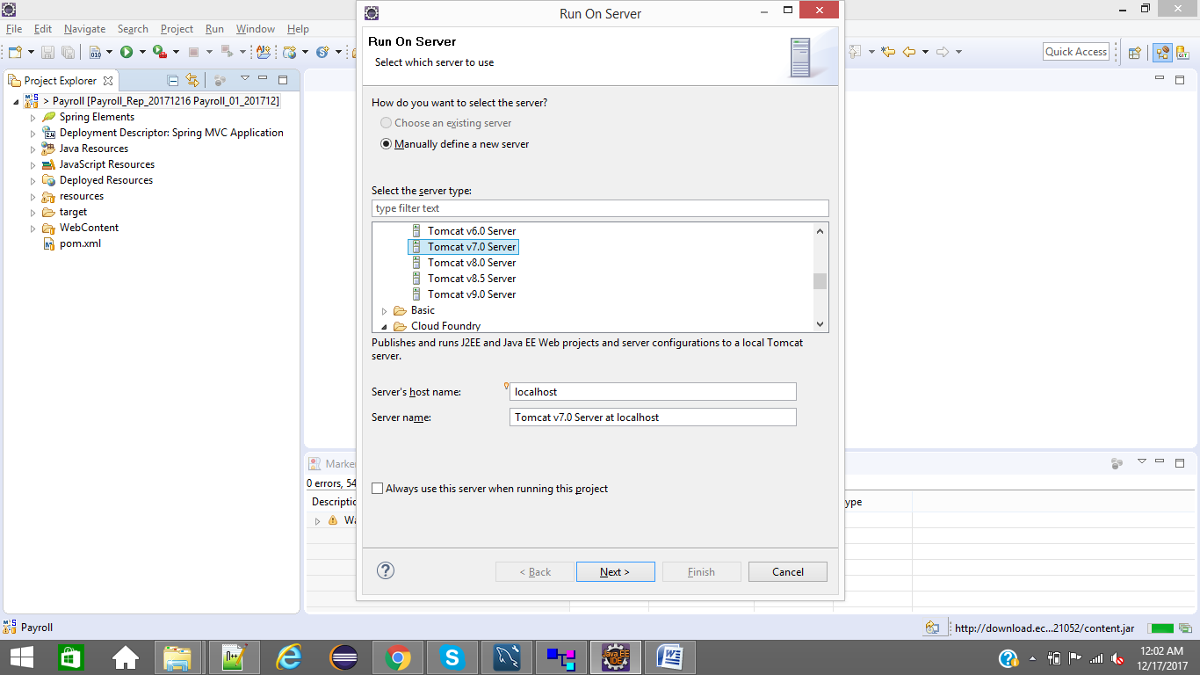

Click on Next button and Choose Tomcat Installation Directory

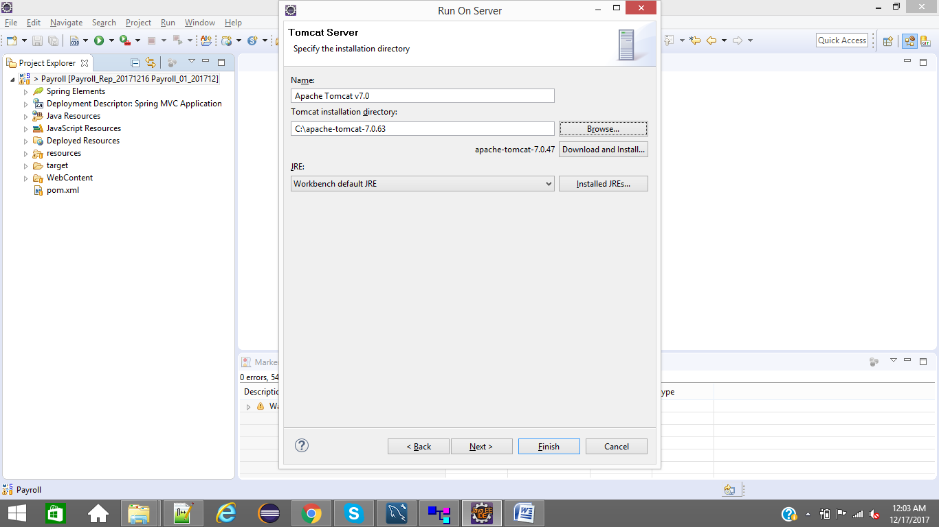

Click on Next button

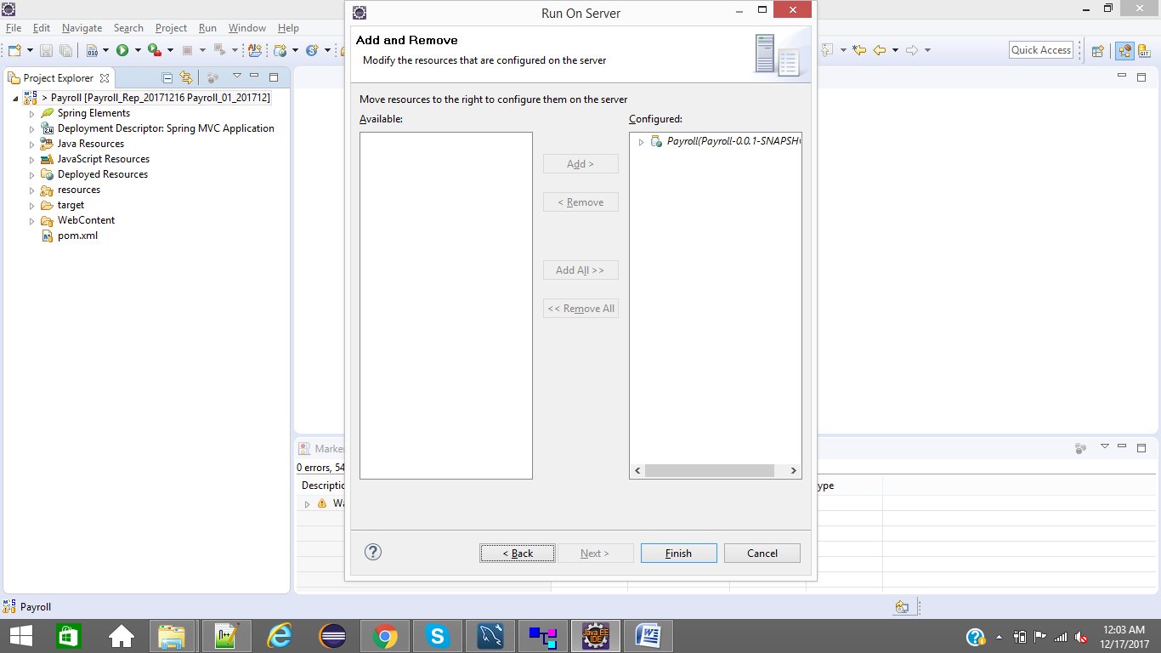

Step#9: Clean Project

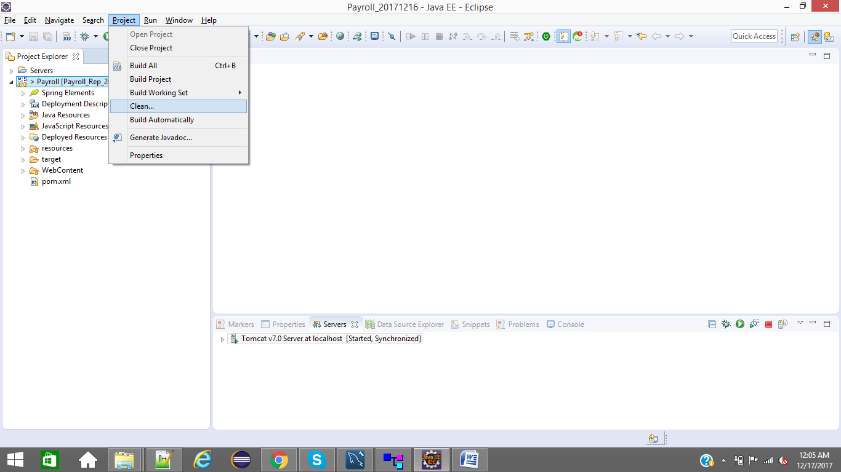

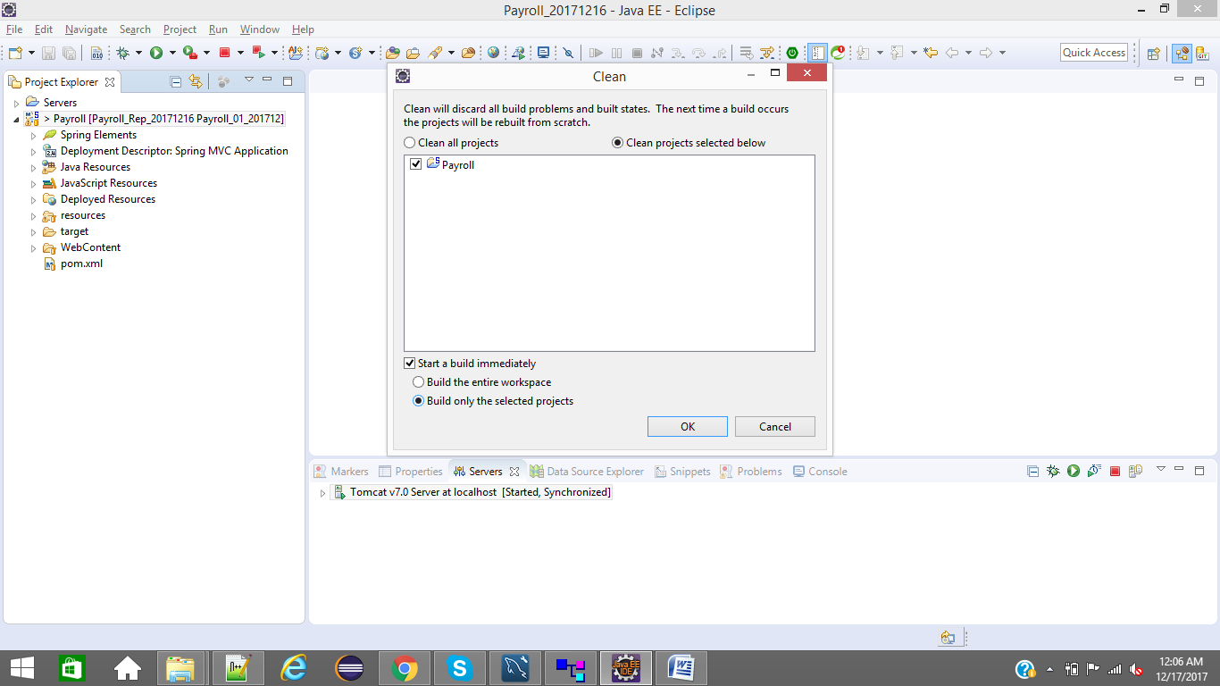

Step#10: Start Tomcat

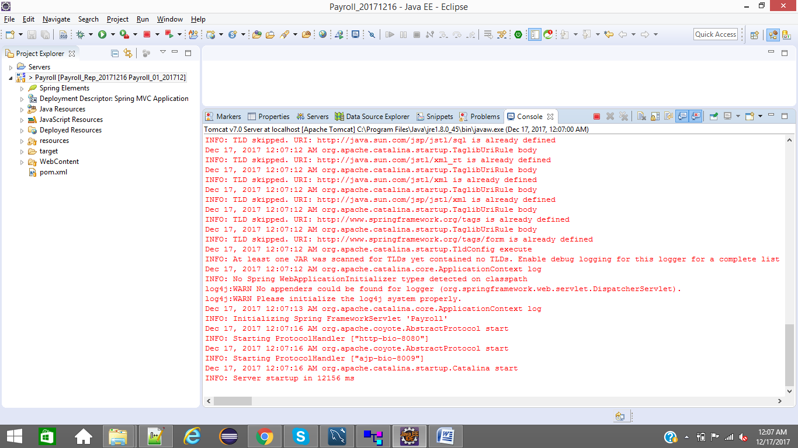

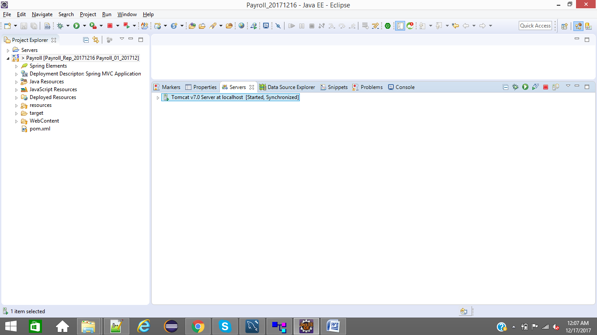

Run following URL in Brrowser

URL: http://localhost:8080/Payroll/dashboard

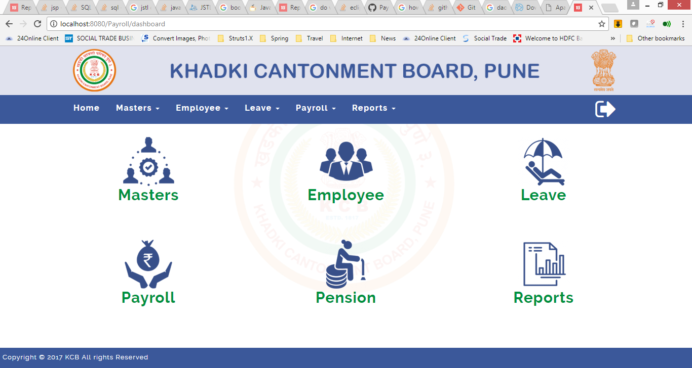

Step#11: if we do any changes to files, we can see it in GIT Perspective - GIT Staging tab

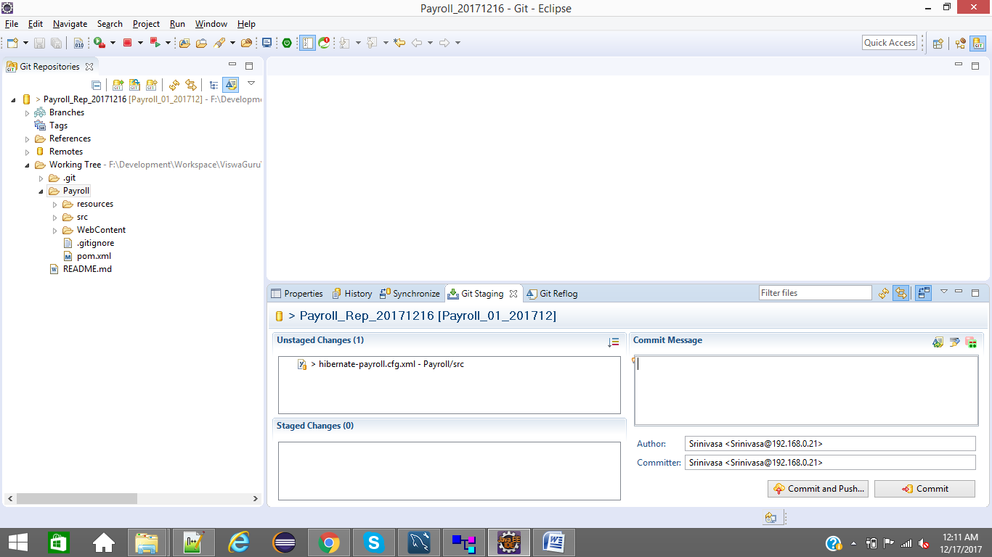

if you want to commit files, you can select and right click from Unstaged Changes and

Select Add to Index

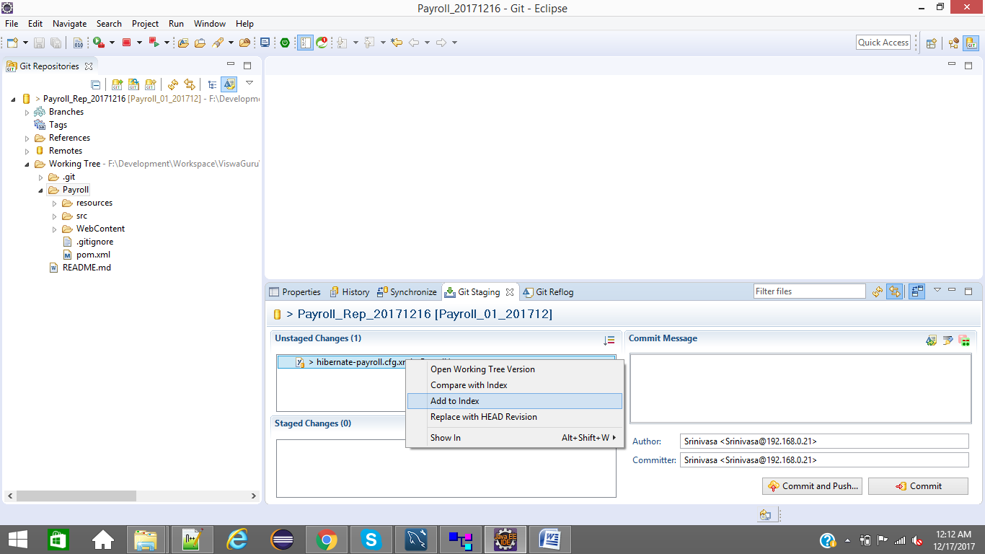

Give proper comments in Commit Message for changed files and click on Commit and Push button

Provide GITHub credentials and click on ok button

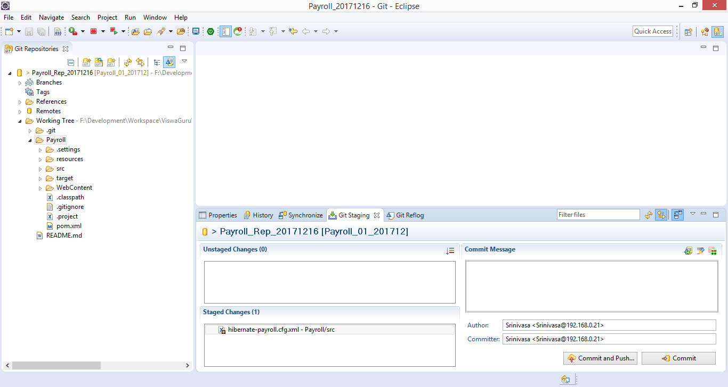

Step#12: Accepting / Merging Repository changes through Synchronize tab

